Project Screenshots

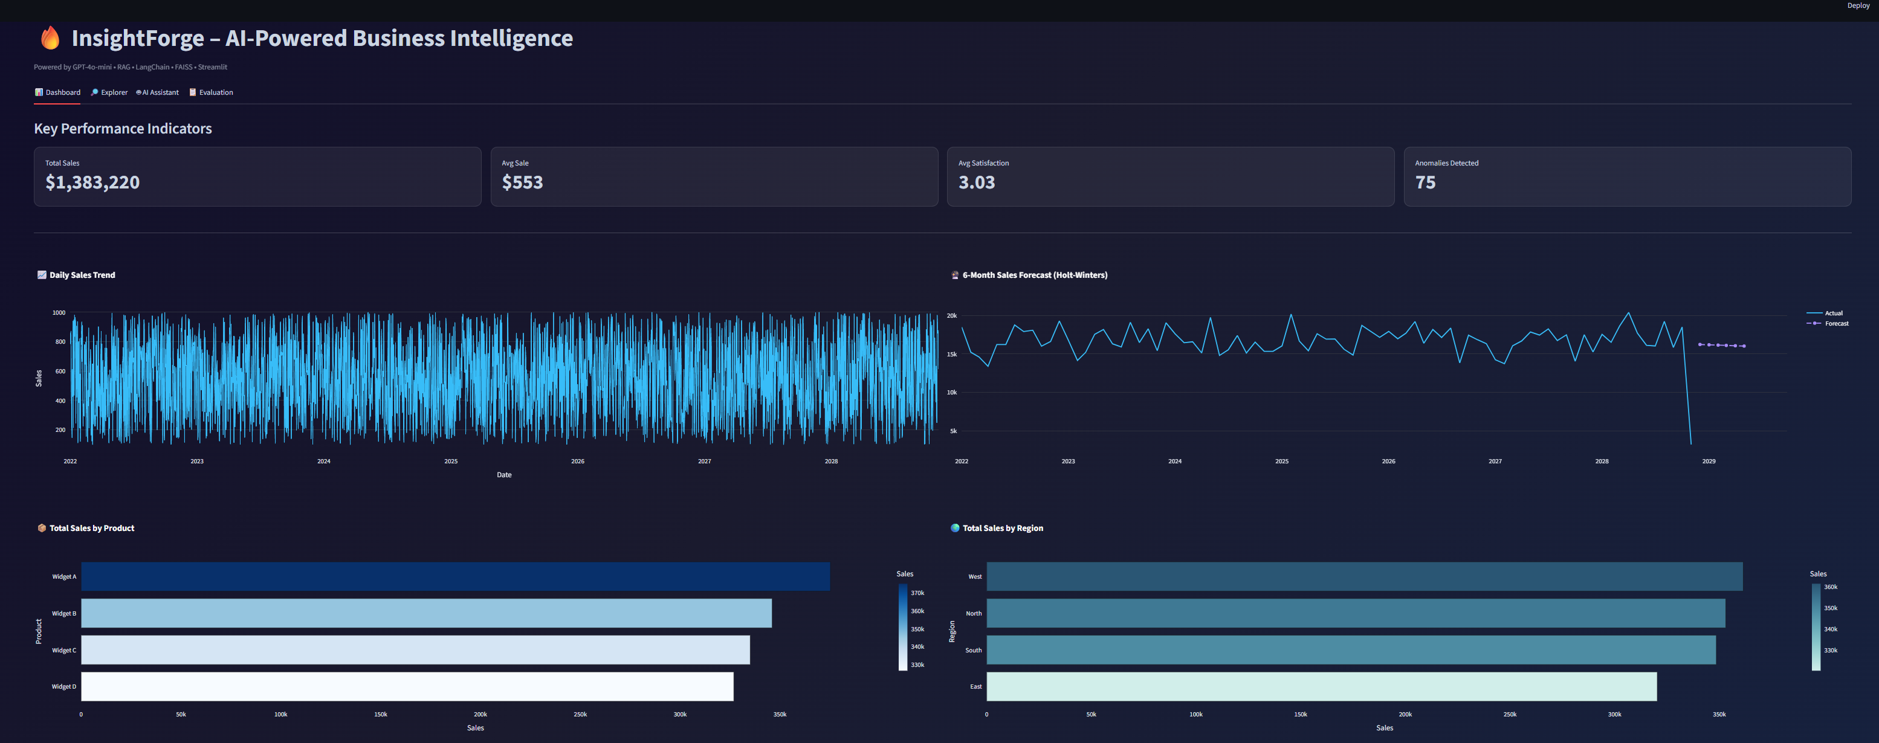
Figure1. Dashboard with KPIs, sales trends, forecasts, segmentation, anomalies, and product/region performance

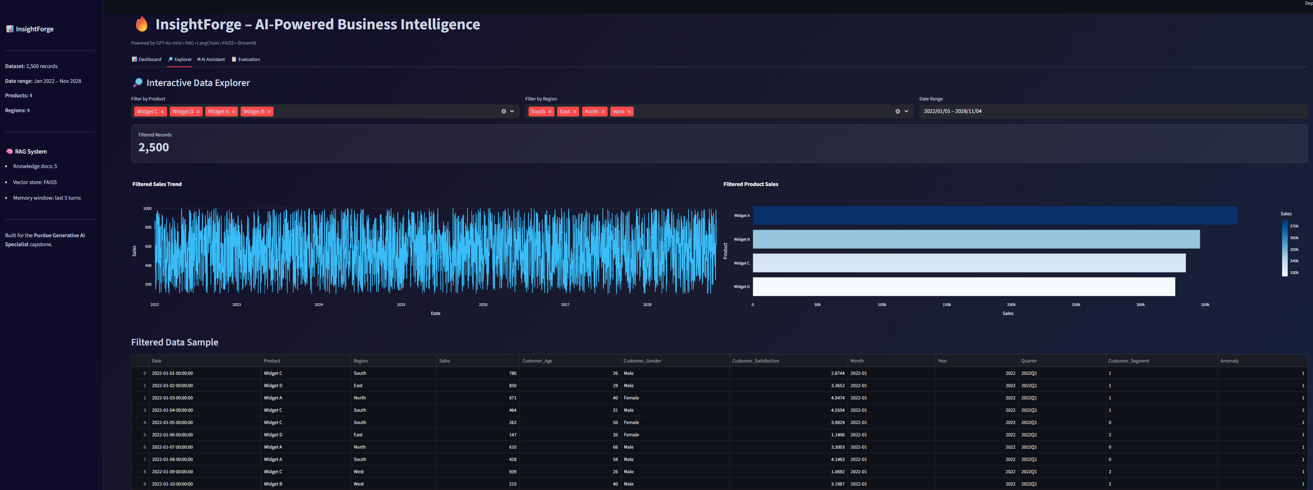
Figure 2. Interactive Explorer with filters and dynamic chart

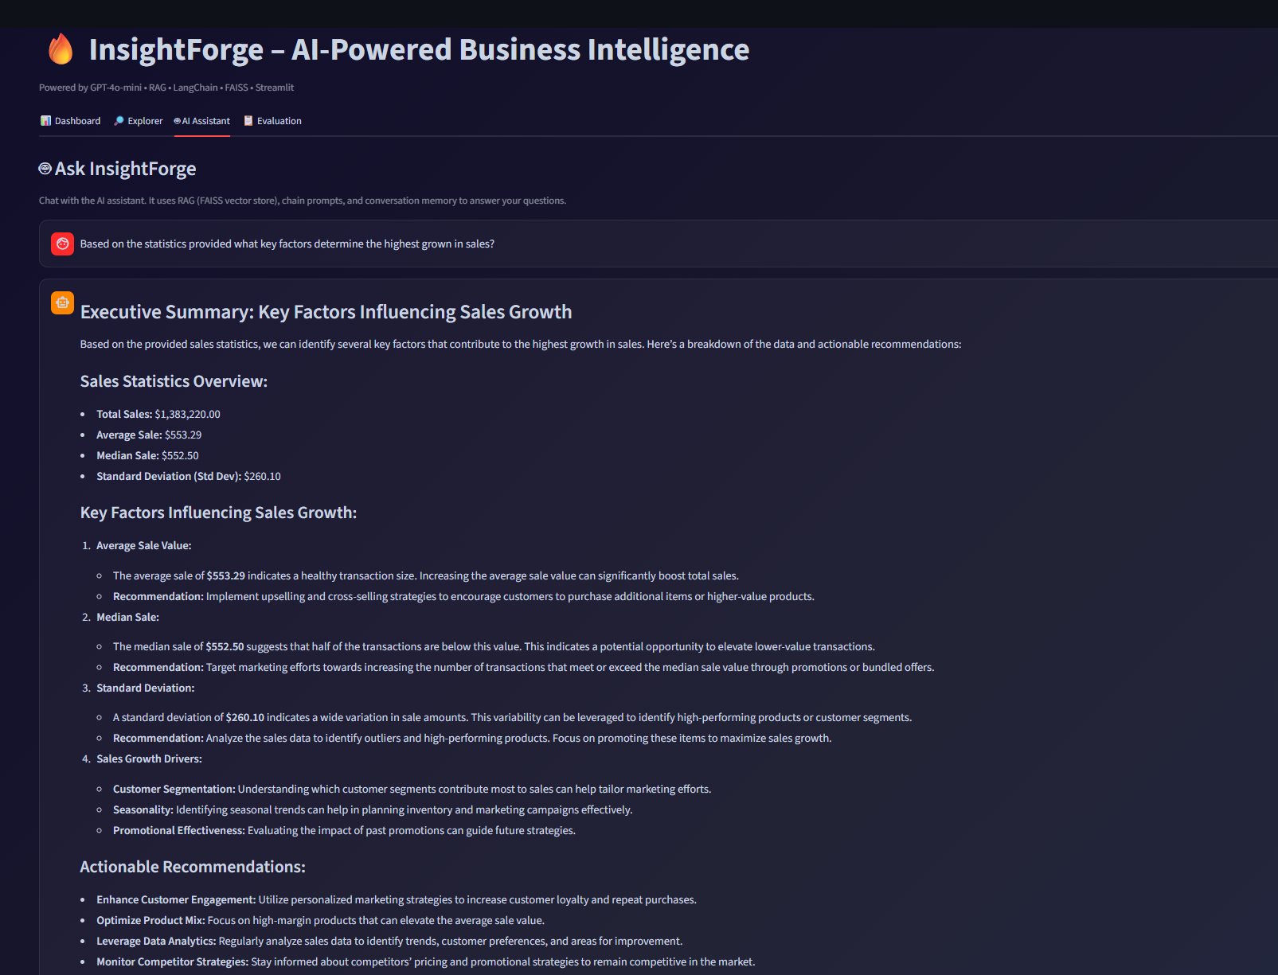
Figure 3. AI Assistant chat interface with RAG-powered insights
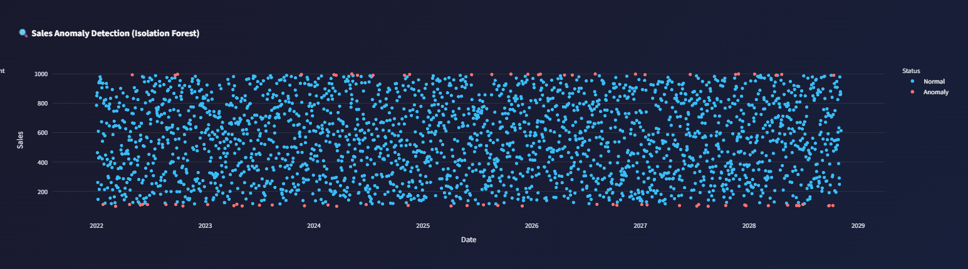
Figure 4. Anomaly detection and alert panels

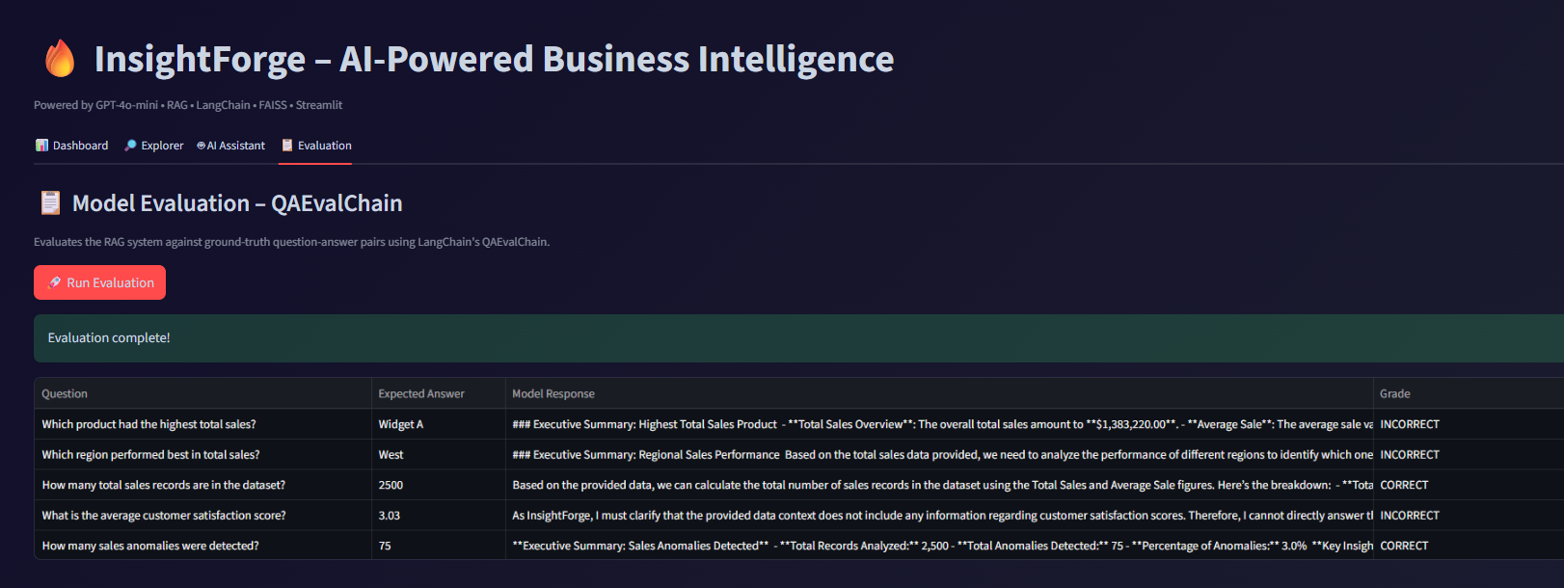
Figure 5. Evaluation tab showing QAEvalChain grading results

